The dislocation of the American Palestinian Protests campaign from the Palestine-Israel contention
José Manuel Mejía Villena

Introduction
In this paper I state that the American Palestinian Protests (APP) produced a dislocated experience of mobilization for the U.S. college/university students, which “sense of realness” held under the primary framework denoted by the Palestine-Israel contention at a multilevel polity scale until certain tipping point marked by the martyrization of Ebrahim Raisi (president of Iran assassinated on May 19th, 2024). After which any keying or reframing effort made by the APP mobilization entrepreneurs was effective to reframe the collective identities, performances, targets, and claims in relation with the Palestine-Israel contention.
Incapable of “determining what it is we think is really going on” (Goffman 1976, 45); while its keying transformation attempts over their subjects toward students unions, the combination of the encampment arrestments, with strikes and march performances, the convenient and secure targeting of the universities/colleges instead than directly target the government, and the fuzzy stablished relation of the APP claims with the Palestine-Israel contention was faraway to have consequences on the genocide perpetuated.
The following approach to the APP is built on the influence of Erving Goffman over the historical political sociology of Charles Tilly, much clear in the translation of the concept of performance to the political contention, emphasizing the necessity to offer attention to “the interplay between cognitive processes and social transactions”, “[modifying] the simplest structural realist position in the direction of social construction” (Tilly 2002, 6). As for Johnston and Alimi (2012, 616), the theory framework I develop here to approach the APP, “followed Goffman’s concepts of primary frameworks, frame rims and keying”, by the recognition of how “the cognitive foundation of primary frameworks helps capture […] deep cultural patterns [that] can influence the ongoing definition and redefinition of collective action”.
The APP (American Palestinian Protests) are identified here as a case of protest campaigns as “as sets of interconnected events sharing similar claims” (Diani and Kousis 2014, 387) executed between September 2023 and June 2024 mainly in the U.S. Rather than counting this events, which can be useful for other purposes than counting for addition, the empirical analysis I am theoretically framing followed the semantic triplets of Franzosi to study the “story grammars” “organized according to a relational format, with subjects related to their actions, actors and actions related to their modifiers, and subjects and objects (both social actors) related to one another via their actions”, but in this case as it’s a contentious campaign, the relevant modifiers for the analysis are the claims or demands.
I will follow the advancements in the literature related to the application of primary frameworks made by Johnston and Alimi (2012) using the semantic triplet Subject-Verb-Object (Franzosi 2006) to explain the dislocation of the performances of struggle of the APP in relation to the historical formation of the elements of the semantic triplet of the primary framework of the Palestine-Israel contention
The mobilization framing of the APP operated modifying the elements of the primary framework manifested by the semantic triplet Subject-Verb-Object configured historically by the Palestine-Israel contention at a multilevel polity scale (Imig and Tarrow 2001) until certain distinguished critical event marked by Ebrahim Raisi’s martyrization, after which the keying of the APP under the Palestine-Israel experienced its own frame limits, evidencing the dislocation of the collective identities assumed, the performances strategically chosen, and their relation with their targets, and consequently the placement or dislocation of their claims.

Theoretical framework
I am holding in the translation of the concept of performance from the interactional framework of Erving Goffman to the transactional framework of Charles Tilly as a category embedded in the theoretical trajectory for the strength of a relational sociology (Emirbayer 1997), to think in the Subject-Verb-Object semantic triplet structure developed mainly by Roberto Franzosi (2006) for the analysis of contentious interactions. Indeed, my argument hold on the theoretical assumption by which the elements of the Subject-Verb-Object triplet configure the organization and govern the definition of the “sense of realness” of the structured individual experience of the events of social life (Goffman 1976, 10-11, 13).
In this particular case, about the events of social life that configured the dynamic of contention of the Palestine-Israel conflict as the primary framework by which the APP acquired meaning, make sense, until a point in which it doesn’t anymore marked by the Joint Statement subscribed by China and Russia in Beijing (May 16th), the Raisi’s martyrization (May 19th), the decision of the ICC for the prosecution of top authorities of Israel charged for war crimes (May 21st), followed by the decision of the U.S. to unrecognize the ICC resolution (May 22nd). The APP demobilization coincided with this tipping point for the Palestine-Israel contention at a multilevel polity scale, and finally the political opportunity was reframed toward the UAW strike completely under the most cooptated and institutionalized organizations to negotiate with the effective repression of the college students, the claims of the students union, claims that difficulty can be understood as disruptive in the broad nor in the precise sense of the term. As Goffman stated properly, frame “limits being a factor to be attended to throughout frame analysis” (Goffman 1976, 49).
The non-keying of the events occurred since May 19th proper of the Palestine-Israel contention by the social movement organizations at the national leadership of the APP finished in “weird” unsuccessful attempts to modify its coalitions, performances, targets and claims. Finally, limited by its own frame, ineffective and completely embedded in its concrete and institutionalized field of contention which is reduced to the university/college campuses. In words of Goffman, the non-keying of the “deviant act” -as an event significant to “undermine the intelligibility of everything else we had thought was going on around us, including all next acts, thus generating diffuse disorder” (Goffman 1967, 5)- , should be contested “[b]y face-work […] to designate the action taken by a person to make whatever he is doing consistent with face. Face-work serves to counteract “incidents”-that is, events whose effective symbolic implications threaten face” (Goffman 1967, 12-13).
An absurd number of detainments were fast paid for also effective liberation, as part of the strategical execution of encampments as performances emulated in around 170 college campus in the U.S. of a total of 180 universities internationally, counted by the creation of its properly labeled Instagram accounts reflected in students4gaza.org. The frame limits of the APP “lived experience” of the Palestine-Israel contention were clearly defined, temporally and institutionally by the deviant act of Raisi’s martyrization (whose responsibility is not in question here), evidencing the impossibility of keying by the APP mobilization entrepreneurs -following the category that McCarthy and Zald (1973) used for the organizational analysis of American contentious politics-.
A contentious theory approach for the APP dislocation in relation with the Palestine-Israel conflict
As for Johnston and Alimi (2012, 616), here my “analytical strategy builds on the non-controversial -in our judgment- assumption that all primary frameworks of contention will minimally have each of these elements [in reference to the semantic triplet Subject-Verb-Object] in some basic way” […] “these three elements -rather than each being fixed and independent of one another-, lifted from a ‘cultural toolbox’ and applied strategically”. The frame-work efforts or keying omissions of the APP mobilization entrepreneurs found its frame limits for the provision of the encampments protest experiences for the U.S. university/college students -mainly ‘undergraduates’ between 17 and 22 years old- after Raisi’s martyrization as the deviant event after which the APP campaign evidenced dislocated from the primary frame contentiously consistent, historically developed in the trajectory toward the jihadization of Palestine struggle for national liberation against Israel occupation at a multilevel polity scale.
In this case the performances executed in the APP were dislocated in relation with the development of the triplets historically formed in the biography of the Subject-Verb-Object semantic triplet, while still providing a lived emotional experience powerfully driven by social media “creating its own special and separate field of existence” (Goffman 1976, 5). In the course of the identification of what I recognize here as a dislocation of the “sense of realness” of the experience produced by the APP, in relation with the frame in which the semantic triplet (Subjetc-Verb-Objetc) of the Palestinian-Israel contention was developed historically at a multilevel polity scale, to not speak about the jihadization of struggles as a set, and the international conflicts completely embedded in the geopolitical biography of the collective identities which have meaning and real political effects, real in their consequences and not only in the lived experience of mobilization created by the APP.
For the recognition of this dislocation, certain deviant act as the martyrization of Ebrahim Raisi -the Iranian President unofficially murdered in a helicopter incident on May 19th, 2024- was necessary to “undermine the intelligibility of everything else we had thought was going around us, including all next acts, thus generating diffuse disorder” (Goffman 1976, 5). This event found the APP completely lost, the attention of the social media dedicated for weeks to stress the “power” of the college students in reaching a “potential” cease fire for freeing Palestine, neither the organizations leading the APP (mainly the coalition Palestinian Youth Movement (PYM) and its national network linked to People for Socialist Liberation (PSL)) failed in keying the frame by which the “transnational” effects of the APP over the Palestine-Israel contention had “sense of realness”, especially after the monolithic U.S. statement of unrecognition of the ICC decision to prosecute Israel authorities for war crimes. Juncture in which the APP, rather than reframe its target from the “university divest” to approach an anti-governmental direct contestation against the U.S. state decision to unrecognize the ICC resolution -which contrary would facilitated a diplomatic solution for the Palestine genocide by the war crimes of Israel-, toward the trajectory for a national UAW strike, absolutely institutionalized and dislocated from the Palestine-Israel contention, and also from the embodiment of the collective identity effectively repressed that was constituted mainly by undergraduate students unrelated to the UAW strike, framing the political opportunity created by the APP.
The deviant act of Raisi’s martyrization and the “dead point” response of U.S. to the ICC decision, was preceded by the Joint Statement subscribed by Vladimir Putin and Xi Jinping in Beijing on May 16, 2024, asking directly for the diplomatic resolution of the Palestine-Israel conflict inside the international state system “ruled” by international law. The response of Biden justified the unnormal intensity of the repression until then executed against the college students mobilized in the APP, but also dislocated the framework in which their claims offer a “sense of realness” to the mobilizing efforts of the college students bitten and detained by police repression.
The “cease fire”, “free Palestine”, “divest” main claims of the APP then, “experience” the impossibility of escalation only by the magic “transnationalization” of a “struggle”, which were labeled as “a global movement” or presented as a “globalized Intifada”, as if the process of escalation of political contention from the local to an international multilevel polity could be reached only by the sole operation of cognitive mechanisms as the attribution of threat/opportunity, or the frame building developed mainly by academics and social movement entrepreneurs related to the APP by certain coalitions shared with the leadership nationally organized under the umbrella of the PYM-PSL coalition.
While the interpretations and performances nurturing the "experience" of struggle flourished instantly in the U.S., mainly organized by Palestinian Youth Movement (PYM) and its national network linked to People for Socialist Liberation (PSL) particularly strength in the state of California -if not in the overall southwest of the U.S.-, developed a well-funded and equipped national campaign of detainments triggered by a well-developed performance of "antagonization of police" to reach "radicalization" and "escalation", but clearly, without "direct action". The APP encampments performance, finally, directed to a great defeat, leveraged by the self-imprisonment and self-martyrization which are the outcomes of the mobilization of sacrificed “political commitments” which supposed to clean the faces of ethical individuals mobilized mainly by its "transnational" link to the Palestine-Israel contention. Those performances were developed in dislocation from the real power dynamic on which the APP have null effects, and furtherly out of a face in relation with the “pace and tone of a more lethal and deadly cycle of contention labeled al-Aqsa Intifada, denoting a religious ardor of the struggle against the Israel-Jewish enemy” (Johnston and Alimi 2012, 616), after Raisi’s martyrization.
The encampments will be over between June and July of 2024, following its institutionalized trajectory of mobilization and coincident with the commencement of the U.S. national pre-campaign for presidential elections, the APP finished with a well coopted labor union completely integrated in the U.S. political system. The "experience" created for the university/college U.S. students nationally, promoted a "global" image of complete defeat of the Palestinian struggle in its cruelest moment, showing a particular “face” to the historical resistance of the people of not only Palestine, but for elsewhere around the world.
The face of armed struggle showed by Hamas, among other propaganda and political organizations of the Palestinian struggle for liberation against Israel in their contentious biography, were obscured by the defeating images of the APP diffused “freely” by social media networks, showing the “experience” of repression as absolute without any attempt to fight against the detainments nor the repression with police by introducing a third party conveniently masked counter-mobilization supposed to be leaded and executed by the “young Zionists” to which the “efforts of resistance” of the APP were mainly directed. Indeed, the police repression acted as policing the APP, regulating the appropriation of the university as a place for the APP contention in exhaust coordination and negotiation with the university authorities in an almost daily base, much in consensus with the executive coalitions under the leadership of PYM-PSL.
What the college students saw as the most powerful student movement since the Vietnam anti-war movement, is really working to produce a global "experience" of defeat of the social forces in struggle against genocide and militarized repression beyond Gaza. The ideological capacity to make the social struggle in the U.S. develop dislocated from the real outcomes of the political situation which is in question in the Gaza crisis triggered by the U.S. government in support of the Israel state building by genocide.
The efforts to provide a manufactured experience of the Palestine-Israel contention to the young population of U.S. university/college mainly undergraduate students, by the encampments-arrestments performances of the APP were oriented to clean, purify, moral individuals, whom by their mobilized emotions believe that their collective action have meaning and are real not only in the experience of being in encampment or of being bitten by police and got arrested for solidarity with Palestine; doesn't matter if they will be "free" by paying a 1000 dollars for each "liberation" after 4 or 5 hours in mean, the “sacrifice” was made and nothing real came from the pronunciation of the chants of “Free Free Palestine”.
Ethics and moral were driven, oriented, disputed and claimed, the target of those efforts was the students for being mobilized, whom in that way became purified, cleaned from individualism by lived solidarity with Palestine. The acts of chanting, marching, striking, encampments-arrestments, are made to produce an experience of mobilization. The performances, claims, targets, subjects, and effects, nothing have to do with the Palestine-Israel contention, but the SMOs of the APP supported by the social media influence on emotions made everything to "appear as if it is". The “sense of realness” rather than the effects of the events, ruled the APP mobilization in an institutionalized trajectory away from the security affair about the jihadization of the Palestine-Israel contention at a multilevel polity, also inside the U.S.
Regarding to the dislocation of the performances of the APP in relation to the development of the multilevel polity contention executed by the different political organs of Palestine (Palestine Liberation Organization, Muslim Brotherhood-Hamas, United National Command of the Uprising), I will be clear in state that the absence of bombing performances, self-immolation, and hostages taken, are armed struggle performances developed robustly in the field of contention formed in Gaza as a response to U.S. imperialist colonial policy and Israel occupation. The jihadization of the Palestine-Israel contention not only in Gaza or the Middle East, but also concretely in the U.S. and Europe since the 90’s motivated a “large scale and frequent use of undercover [Isarel] squads. Soldiers od special units named ‘Doovdevun’ (Cherry) and ‘Shimshon’ (Samson) […] also prepared or formed “to join crowds of stone throwers to identify the ‘hard-core’ activists” (Johnston and Alimi 2012, 615).
During the current breakdown of the legitimacy of the international state system, the crisis in Gaza and the genocide of Palestine has been framed highly influenced by social media infrastructure (Instagram, Twitter and Signal) as a "transnational" field of contention, at the point to declare a “global student’s movement”, or the most powerful student movement in American history in comparison with the Vietnam anti-war movement.
If we look at the consequences of the APP, completely descripted by their claims, the effects on the Palestinian genocide is null, the reason why, is not only because of the “cease fire”, “divest” and “free academic liberties” were claims completely out of the primary frame configured by the Palestinian-Israel contention historically, but mainly because of the channeled manner in which the APP selected their targets avoiding to target the government in a desperate move to reduce its scope to the college students movement field of contention avoiding it direct framing as an anti-government protest. In that manner neither the claims, nor the performances could have any effect on the real situation of Palestinian genocide but provide a lived experience with a “sense of realness”, finally dislocated, unsuccessful, and demoralizing.
The constrain of the performances and its spatiality, while being declared “transnational”, clearly diminish and control effectively the escalation and radicalization of the performances of struggle which are proper of the jihadization of the Palestine-Israel contention. Holding the actors, the performances, the claims, and the targets of the APP completely under cooptation and under the institutionalized trajectory of mobilization proper of the “special and separate style of existence” of the encampments at U.S. university/colleges in which “certain reality” as the APP was attended, acquiring a “sense of reality” by the emotional lived experience of a “global” juncture.

Conclusion and prospective research agenda
A further development of empirical analysis is required to evidence the efficacy of technological dispositives creating a visual culture for the mass mobilization of emotions by triggering the operation of cognitive mechanisms of political contention as the mechanisms of framing, and the mechanism of attribution of opportunity/threat for collective action. While this mechanisms and the platforms used as Twitter/X, Instagram, Facebook, and Signal, depended on preparation of virtual and social networks by the SMO’s of the APP following an ordered strategy of monolithic and controlled diffusion of images, slogans, hashtags, supported by the infrastructure of profiles and accounts certified by the core leader SMO’s to nurture a demonstration of the efficacy of their strategical approach to control “spontaneous” episodes of contention among a particular kind of mobilized mass mainly young middle-upper class and white, in contrast with the multiracial and much more transgressive episode of 2020 in the U.S. labeled latter as Black Live Matter (BLM).
The experience provided by the APP, manufactured a “sense of realness” of the “globalization” of the Palestine-Israel contention effectively lived with bites, peeper gas, rubber bullets, and blood, faced to the world by “live stream”. A fact at least “puzzling” and surprisingly contrastable, with the completely banned access to internet and phone signal restricting almost completely and in real time the diffusion of images of similar and higher levels of police and military brutal repression in contemporary episodes of contention as Ukraine 2018, Ecuador and Chile 2019, Colombia 2020 and 2021, Peru 2022, just to mention a hand of them. The APP was powerfully emotionally driven purposefully over a very young population which evidenced behaved and responded particularly to the operation of cognitive and relational mechanisms of mobilization, being rapidly mobilized also because of the resonance of “their own” voices, images, videos, records of their “own experience” of the Palestine-Israel contention “freely” through social media and powerful corporative platforms as Instagram, Facebook, Twitter/X, clearly non-neutral actors at a multilevel polity scale.
A methodological approach to evidence the APP frame-work dislocation from the Palestine-Israel contention can be designed from the observant participation, ethnography, and visual culture analysis, by identifying the categories relevant for a further text analysis based on the social media publications of the approximately 180 Instagram accounts which reported encampments to the platform students4gaza.org, mainly in U.S. university/colleges between April and June 2024.
In the following Figure 1, I show an initial map of the contentious politics denoted by the APP identifying the elements of the semantic triplet Subject-Verb-Object and it’s claims, configuring, structuring experience manufactured by the APP encampments using the network tool of ATLAS.ti 22. The purpose of these initial analysis of the visual culture and documents was to take the University of California Santa Barbara (UCSB) encampment as a case for exploratory research by identifying the consistency and/or dislocation of the framing efforts in relation with the primary frame denoted by the Palestine-Israel contention after the deviant act of Raisi’s martyrization.
The codification of its SMOs, performances, targets, and claims visually present in the UCSB encampment, support the construction of the categories for further empirical research using text and visual analysis of the APP under this theory framework which I found useful to understand the frame limits of keying collective identities, performances, targets, and claims until a tipping point in the Gaza crisis after which the demobilization timing of the encampments-arrestments performance, the trajectory of institutionalized mobilization, collective identities biographies, and strategical targeting, clashed with deviant acts as the Raisi’s martyrization.
Finally, dislocating the framing/keying efforts of the APP to make sense of the “experience” of a globalized Palestine-Israel contention, finally disappearing without the realness of the expected consequences I consider should have for the young students mobilized to the experience of pure police repression, which without any capacity for direct contestation to police brutality and arrestments found its limitations to escalate, as if the escalation of contention to a multilevel polity scale is a matter of experimentation.
Figure 1. Visual culture of the APP encampment in UCSB to map the Subject-Verb-Object-Claims or the Collective Identity-Performances-Targets-Claims
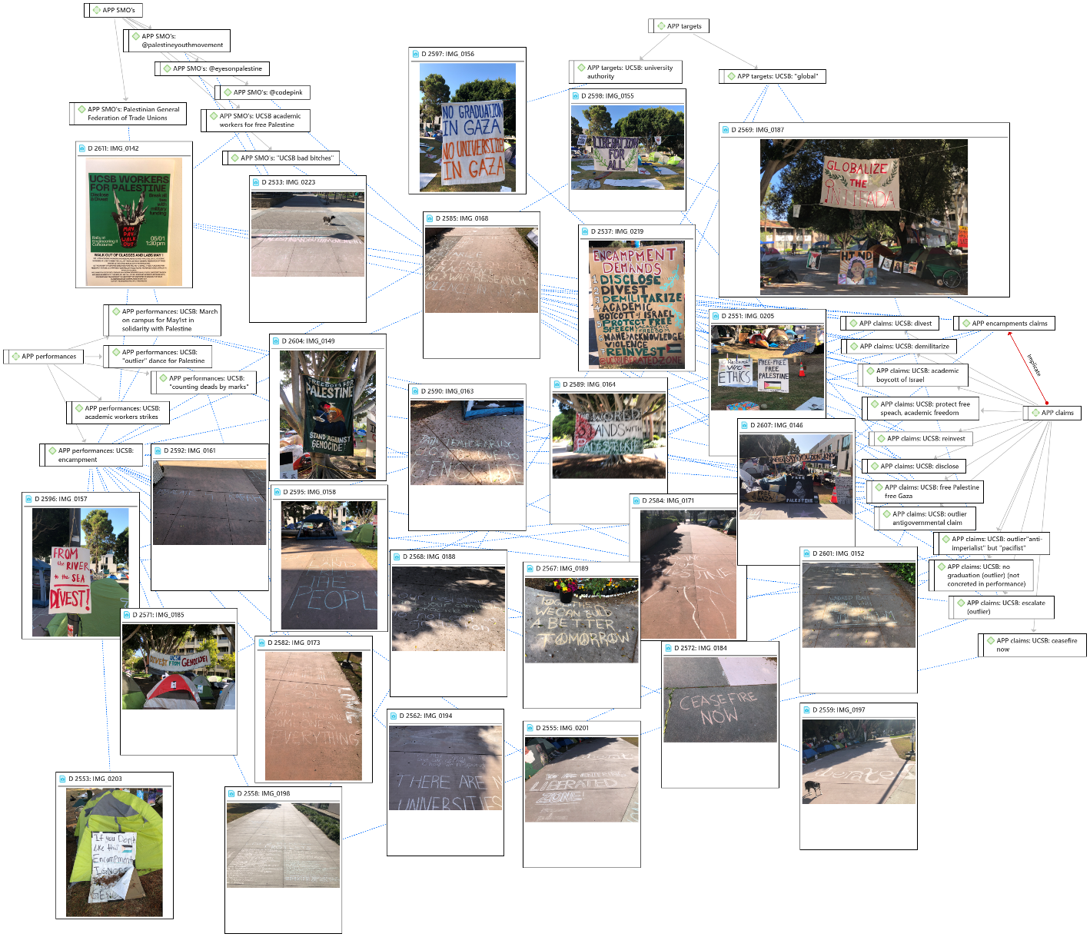
Source: Elaborated by the author using ATLAS.ti 22.
Cited references
Diani, Mario, and Maria Kousis. 2014. “The Duality of Claims and Events: The Greek Campaign Against the Troika’s Memoranda and Austerity, 2010-2012.” Mobilization: An International Quarterly 19 (4): 387–404. https://doi.org/10.17813/maiq.19.4.d865w28177575673.
Emirbayer, Mustafa. 1997. “Manifesto for a Relational Sociology.” American Journal of Sociology 103 (2): 281–317. http://www.jstor.org/stable/10.1086/231209.
Franzosi, Roberto. 2006. “The Return of The Actor. Interaction Networks Among Social Actors During Periods of High Mobilization (Italy, 1919-1922).” Mobilization: An International Quarterly 4 (2): 131–49. https://doi.org/10.17813/maiq.4.2.480g12700535663l.
Goffman, Erving. 1967. Interaction Ritual: Essays on Face-to-Face Behavior. [1st ed.]. Anchor Books ; A596. Garden City, N.Y: Doubleday.
Goffman, Erving. 1976. Frame Analysis: An Essay on the Organization of Experience. Cambridge, Mass: Harvard University Press.
Imig, Douglas R., and Sidney Tarrow, eds. 2001. Contentious Europeans: Protest and Politics in an Emerging Polity. Governance in Europe. Lanham, Md: Rowman & Littlefield.
Johnston, Hank, and Eitan Y. Alimi. 2012. “Primary Frameworks, Keying and the Dynamics of Contentious Politics: The Islamization of the Chechen and Palestinian National Movements.” Political Studies 60 (3): 603–20. https://doi.org/10.1111/j.1467-9248.2011.00927.x.
McCarthy, Jhon D. John D., and Mayer N. Zald. 1973. “The Trend of Social Movements in America: Professionalization and Resource Mobilization,” 30–30.
Tilly, Charles. 2002. Stories, Identities, and Political Change. Oxford: Rowman & Littlefield Publishers.

“I am not addressing the structure of social life but the structure of experience individuals have at any moment of their social lives” (Goffman 1967, 13). The perception of reality is given, ruled, oriented, structured by frames, which are “these basic elements” configuring the “sense or realness” of a situation, event, “made real for us in its own special and separate style of existence”. Only then, “certain reality is attended”. (Goffman 1967, 2, 10-11).
For Roberto Franzosi (2006, 133) the relational turn is not a kind of structuralism and implied a refocus on social interactions rather than social structures, warning also that the theory development on this direction “was partly made possible by the development of new tools of data analysis, network models, that operate on data that measures relationships among actors rather than properties of actors”. It’s vital to this point in time, to take seriously the warning of Franzosi. The relation between technology advancements and the development of social theory as the outcomes of this relationship is not only data-driven but theoretically oriented, and in the outcomes of social life the sociological intervention is political.
Published in: http://en.kremlin.ru/events/president/news/74049 [Accessed at May 19th, 2024).

